**Assignment 1**

**Problem Statement:-** Create an AWS account and configure a budget

# **Solution:-**

1. **Create AWS account**

**Step 1.1:** Go to your preferred web browser and search https://aws.amazon.com/ to create an account.

**Step 1.2:** Choose **Create an AWS Account.**

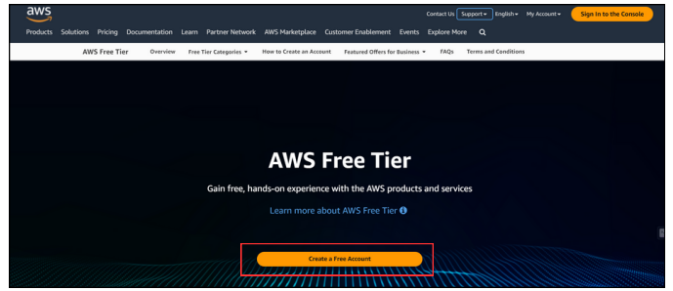

**Step 1.3:** Enter an email address and an account name, then verify your email address by the verification code you received through your email.

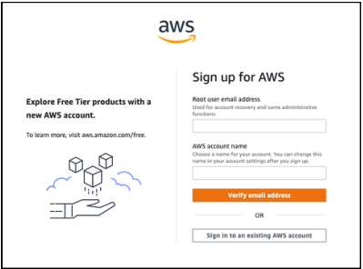

**Step 1.4:** Create your **root user password.**

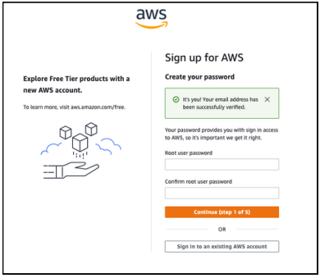

**Step 1.5:** Choose between a business or personal account and your billing details.

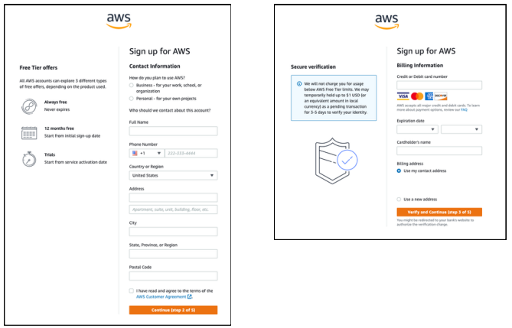

**Step 1.6:** Choose how you want to confirm your identity and choose Basic support - Free to create a Free AWS account.

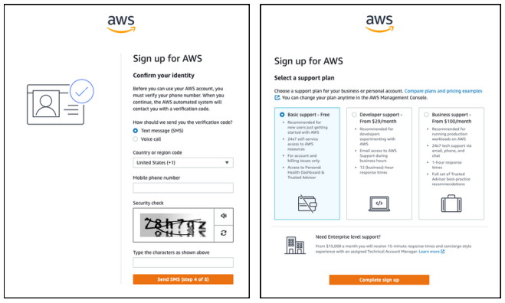

1. **Configure Budget**

**AWS Budgets is the simplest way to monitor your AWS spend and be alerted when you exceed or are forecasted to exceed your desired spending limit.**

**Step 2.1:** Open your AWS Console, click on your account and click on Billing and Cost Management.

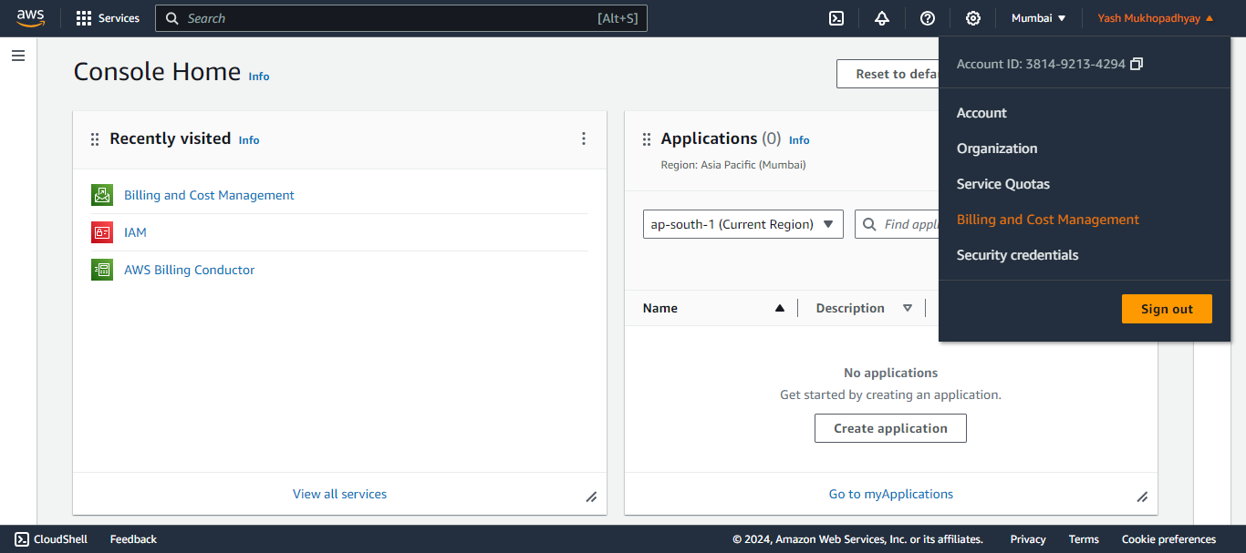

**Step 2.2:** Go to Budgets and then click on Create Budget.

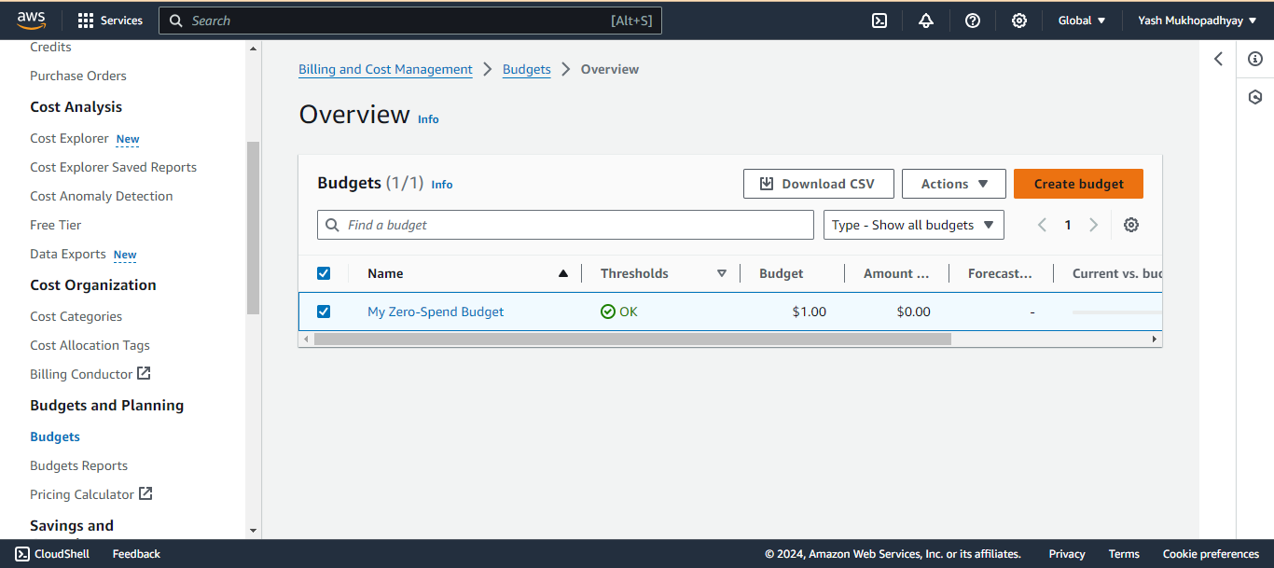

**Step 2.3:** Choose the budget type, you can use a template or customize it on your own to create a budget.

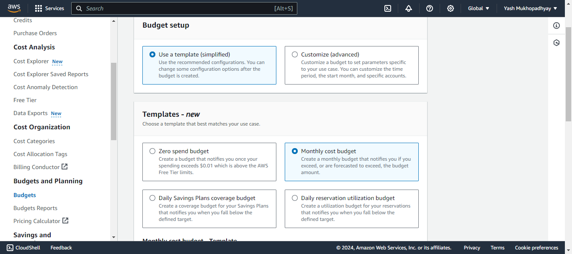

**Step 2.4:** Choose the budget name, the amount you can spend on the given budgeting period, and the email address(es) where you are willing to get the alerting emails. Then click on Create Budget to complete your budget creation.

